Streets and Streams: Our Baltimore Environment

June 27th – July 1st 2016

CBF Course Leader | CBF Course Leader
Jocelyn Tuttle  JTuttle@cbf.org  443-604-4621 | Ian Robbins  IRobbins@cbf.org
Mentor Teacher | CBF Office Point of Contact
Vicki Mathew  vsmathew@gmail.com | Amy Green  agreen@cbf.org  443-482-2054

Course Description
This course has been developed for secondary teachers in Baltimore City Public Schools

Come explore the interactions between our urban systems and the Chesapeake Bay. This five-day course focuses on how to engage your students in field-based investigations into issues affecting our local environment. We will investigate ways that human activities and choices impact the ecosystems and natural habitats of the bay through the collection, analysis, and interpretation of authentic data. Participants will take home an array of activities and lessons that can be incorporated into the school curriculum.
Length & Location: 5 days in the Baltimore region

Course Objectives
Though participation in this course, teachers will:

- Learn how we can productively use the environment as a context for disciplinary learning in the field and in the classroom.

- Examine some of the ways that urban development in our area has impacted the ecosystems and natural habitats of the Chesapeake Bay.

- Identify and evaluate solutions for monitoring and minimizing human impacts on the Bay.

- Engage in some of the practices that scientists use when investigating water quality in order to make predictions about the health of Chesapeake ecosystems.

- Use maps, satellite images, photographs, and other representations to explain the environmental characteristics and the relationships between the locations of regions.

- Analyze the impact and the appropriate roles of personal interests and perspectives on the application of civic virtues and democratic principles with regard to managing and regulating Chesapeake resources.

Standards-based alignment
This course has been designed to support the following standards:

- Maryland Environmental Literacy Standards
- Environmental Issues
- Interactions of Earth’s Systems
- Flow of Matter & Energy
- Populations, Communities, and Ecosystems
- Humans and Natural Resources
- Environment & Health
- Environment & Society
- Sustainability
- Next Generation Science Standards (NGSS)
  - LS2.A Interdependent relationships in Ecosystems,
  - LS2.C Ecosystem dynamics, functioning and resilience,
  - LS4.D Biodiversity and humans,
  - ESS3.C Human Impacts on Earth Systems
- College, Career, and Civic Readiness Standards for social studies (C3)
- Dimension 2: Applying Disciplinary Concepts & Tools: Civics
- Dimension 2: Applying Disciplinary Concepts & Tools: Geography

Course Materials:
Course Text:

Each teacher participant will receive a pre-course reading from Tom Horton’s Turning the Tide via e-mail. They will also receive a hard copy of the Lippson and Lippson’s Life in the Chesapeake Bay.

Teacher Resource Guide:
Teachers will be provided a workbook that will serve as a field journal to record observations, activities, reflections and resource information.

Classroom Resources:
Each teacher will receive a Chesapeake bay Watershed Map and a poster identifying common Land Use around the Bay via Satellite image as well as hand-outs provided by guest speakers during the course.

Course Assignments
Final Project:
- A Curriculum Integration plan
  - This assignment is an opportunity for teachers to demonstrate how they might translate the knowledge and skills developed in the field into meaningful learning experiences for their students.
- Curricular Integration “Self-Check” Rubric
  - This rubric will serve as a resource for the development and refinement of teachers’ Curriculum Integration Plans.
- Written reflection
  - This essay will focus on how field-based investigations and civic action may be used to support Montgomery County’s Environmental Literacy plan.

Course Evaluation:
Participants are given an opportunity to complete a comprehensive evaluation at the conclusion of the course. CBF, via the mentor teachers, will also survey participants once in the fall and spring following the course to assess and record their experience implementing their Plans.

Schedule for the Week

Course Driving Question: How can Baltimore City teachers connect their students and school community to the local environment and the Chesapeake Bay?

Day 1: June 27th
*PLEASE CARPOOL-parking is limited*

Timing and Location: 8:30 AM- 4:00 PM→ Great Kids Farm
6601 Baltimore National Pike (Route 40)
Catonsville, MD 21228

- Investigative Question(s):
- What is a watershed and why should my students care?
- How does the land’s health affect the water’s health?
- How do I know if a waterway is healthy?
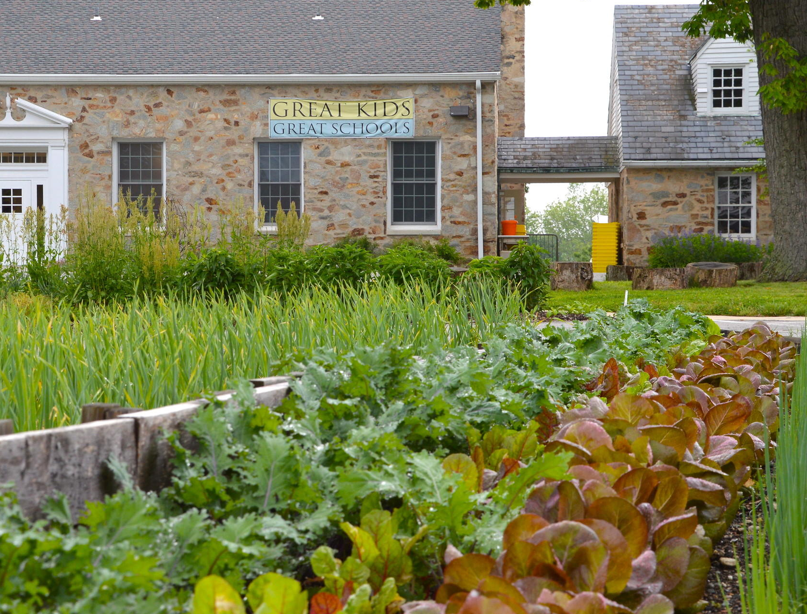
- What we’ll be doing:
  - Staff and participant introductions and get-to-know-you activities.
  - Reviewing the course requirements, syllabus, and plan for the week.
  - Acquiring a sense of place and appreciation of our local environment through watershed and map activities
  - Learning about the educational opportunities available at Baltimore City Public School’s Great Kids Farm.
  - Investigating and walking through a local stream to collect our first set of water quality data.

- What you will need:
- completed CBF Health Form to be handed to course instructors
- pack a lunch and bring a reusable water bottle
- course syllabus and pen or pencil
- hat, sunscreen
- closed-toe walking shoes that can get wet and dirty and a change of shoes to go home in
- clothes that you don’t mind getting a little wet and dirty
- CBF will provide snacks and water for refills throughout the day

Day 2: June 28th

Timing and Location: 8:30 AM-11:00 AMPatapsco Waste Water Treatment Plant
3501 Asiatic Avenue
Baltimore, MD 21226
11:00 AM-1:00 PM Middle Branch Park (for lunch and activities)
3301 Waterview Avenue
Baltimore, MD 21230
1:30 PM-3:30 PM Wheelabrator Baltimore
1801 Annapolis Road
Baltimore, MD 21230

- Investigative Question(s):
- How do our personal choices and waste affect the environment and Chesapeake Bay?
- How much do my students and I know about the end result of our waste?
- What lessons can I take away from my experiences today to share with my students?

- What we’ll be doing:
  - Touring the Patapsco Waste Water Treatment Plant and the Wheelabrator energy-from-waste facility
  - Modeling some lessons that can be done with students regarding water, waste, filtration, and pollution.

- What you will need:
- pack a lunch and bring a reusable water bottle
- course syllabus
- Teacher Guide/Journal and pen or pencil
- hat, sunscreen
- closed-toe walking shoes that may get a little dirty
- clothes that you don’t mind getting a little wet and dirty
- CBF will provide snacks and water for refills throughout the day

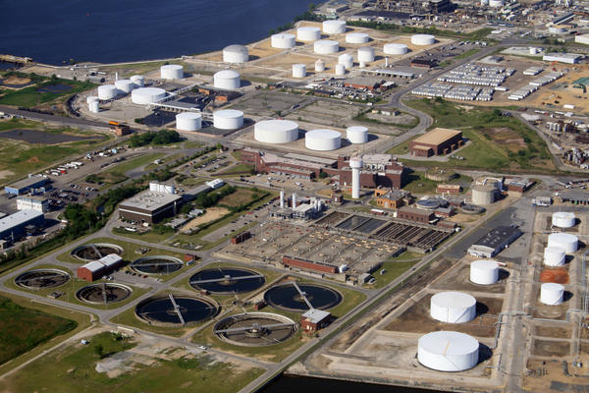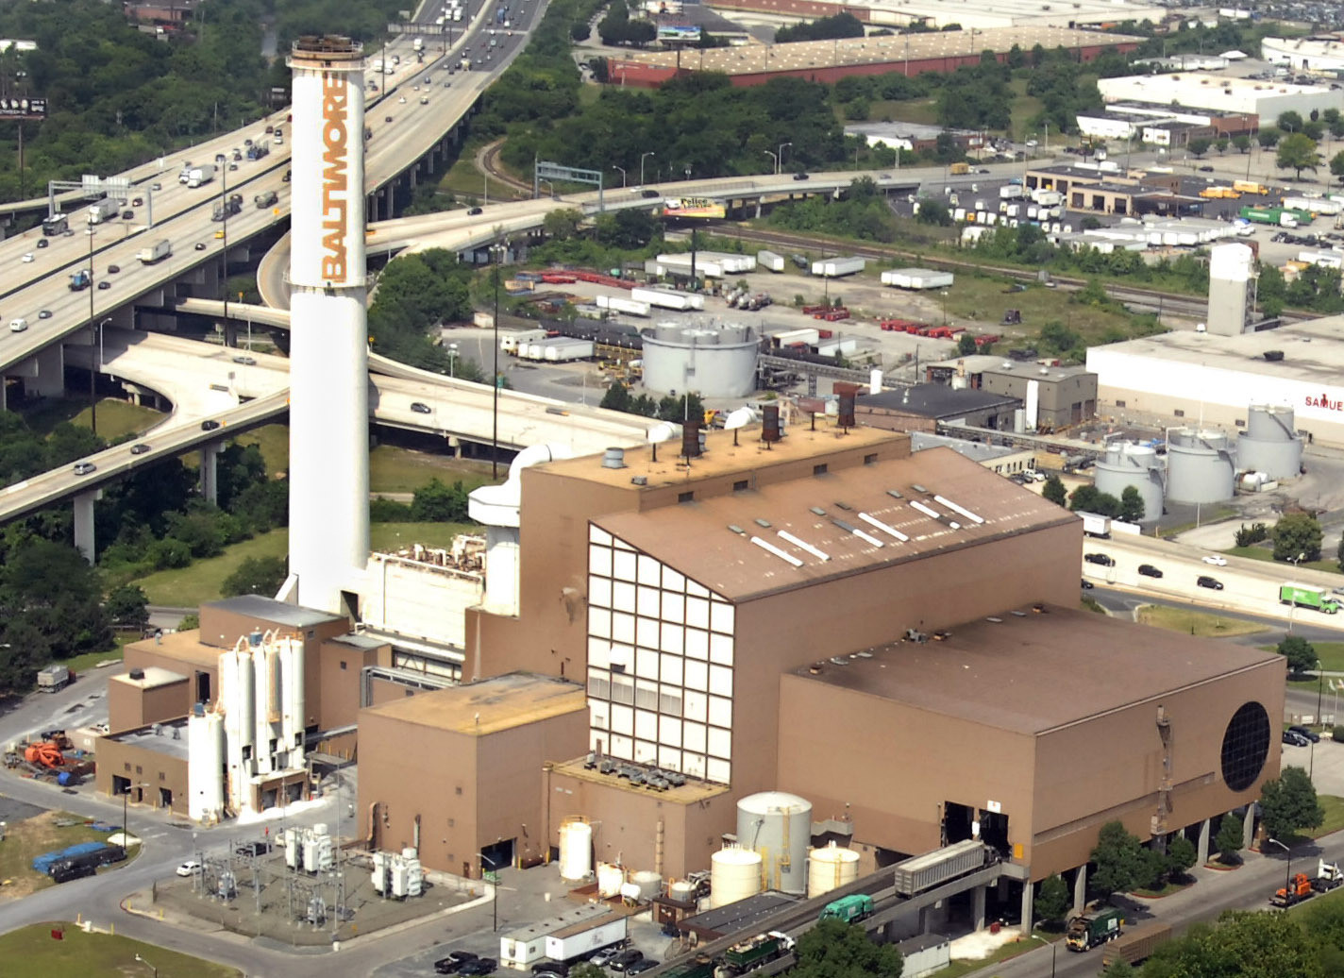

Day 3: June 29th
*PLEASE CARPOOL-parking is limited*

Timing and Location: 8:00 AM- 4:00 PM→ Masonville Cove Environmental Education Campus
1000 Frankfurst Avenue
Baltimore, MD 21226

- Investigative Question(s):
- How has the city’s changing landscape and demands affected the health of the Patapsco?
- Is the water in the Harbor healthy and how can we find out?

- What we’ll be doing:
  - Canoeing on the Patapsco River, testing the water, and discovering the beauty of wetlands along our city’s waterfront.
  - Discussing the impacts that our changing landscape and demands have had on the health of the aquatic environment.
  - Learning about educational opportunities at Masonville Cove both on campus and at the dredge spoil fill sites.

- What you will need:
- Clothes and shoes that you don’t mind getting wet and dirty (sport or water sandals with straps are okay for our morning canoe trip, but bring a pair of closed-toe shoes for the afternoon)
- Change of clothes and shoes for the second half of the day
- pack a lunch and bring a reusable water bottle
- course syllabus
- Teacher Guide/Journal and a pen or pencil
- hat, sunscreen
- CBF will provide snacks and water for refills throughout the day

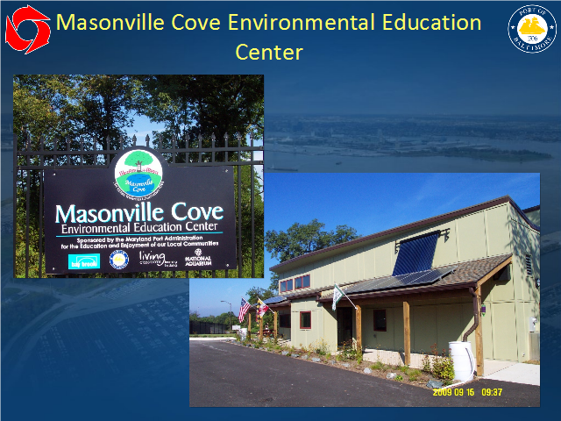

Day 4: June 30th
*PLEASE CARPOOL-parking is limited*
Timing and Location: 8:30 AM- 10:30 AM→ Blue Water Baltimore Headquarters
3545 Belair Road
Baltimore, MD 21213
11:00 AM-1:45 PM→ Lake Clifton H.S. and Real Food Farm
2801 St. Lo Drive
Baltimore, MD 21213
2:00 PM- 4:00 PM→ Afya Public Charter School (our mentor teacher’s home turf)
2800 Brendan Avenue
Baltimore, MD 21213
- Investigative Question(s):
- What are some of the solutions to our environmental problems?
- What is being done in Baltimore City to restore our Chesapeake Bay?
- Is farming good or bad for our waterways?
- What can I do on my school grounds to help my students connect to their environment and the Bay?
- How can I incorporate all that I have learned this week into my classroom curriculum?

- What we’ll be doing:
  - Meeting with staff of Blue Water Baltimore at their green headquarters building and learning about what they do to restore the urban environment.
  - Learning from an alumni of last year’s course and discussing what can be done with your students to connect them to their local environment and the Bay.
  - Touring and learning from the folks at Real Food Farm about urban farming initiatives.
  - Spending time at our mentor’s school to work on our course assignments and complete a school yard report card.

- What you will need:
- A laptop so that we can work on our Curriculum Integration Plans.
- Clothes and closed toe shoes that you don’t mind getting a little dirty
- pack a lunch and bring a reusable water bottle
- course syllabus
- Teacher Guide/Journal and a pen or pencil
- hat, sunscreen
- CBF will provide snacks and water for refills throughout the day

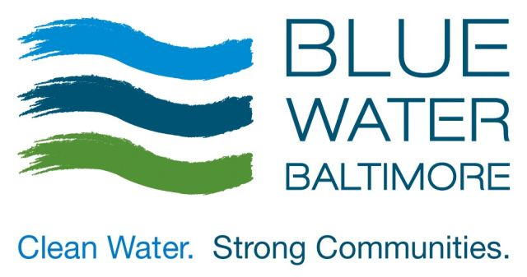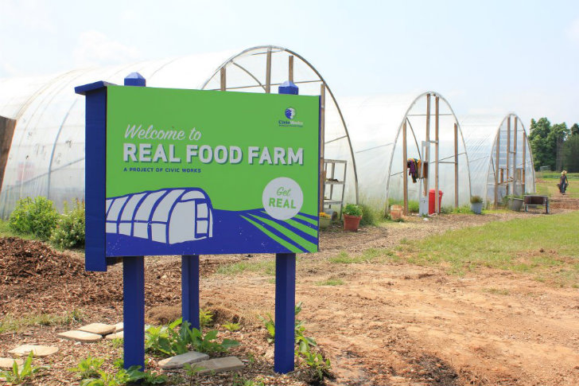

Day 5: July 1st
Timing and Location: 8:30 AM- 3:30 PM→ Canton Waterfront Park
3001 Boston Street
Baltimore, MD 21224

- Investigative Question(s):
- Where does all the water from our streets and streams go?
- Is the water in the Harbor healthy and how can we find out?
- What do the organisms we find in the Patapsco tell us about the city around it?
- How can I keep my passion for Bay and environmental education alive throughout the school year?

- What we’ll be doing:
  - We will investigate the Harbor and larger Patapsco River while aboard the Chesapeake Bay Foundation’s work boat, Snow Goose. We will be on the boat all day, but don’t worry there is shade and you can still drink your morning coffee because the boat has a toilet.
  - Water quality testing and biodiversity sampling
  - Complete a wrap-up and reflection activity for our week together.

- What you will need:
- Clothes and closed toe shoes that you don’t mind getting a little wet and dirty
- pack a lunch and bring a reusable water bottle
- course syllabus
- Teacher Guide/Journal and a pen or pencil
- hat, sunscreen
- CBF will provide snacks and water for refills throughout the day

